# Stefan’s Security

# Web Penetration Testing

Web application Vulnerabilities

* SQL Injection
* Cross site scripting
* Broken Authentication
* Sensitive Data Exposure
* Broken Access Control

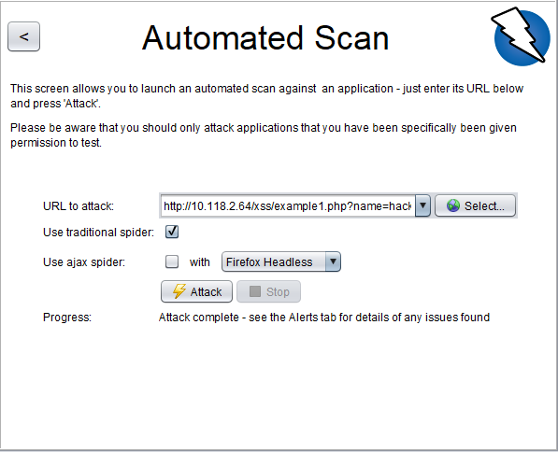

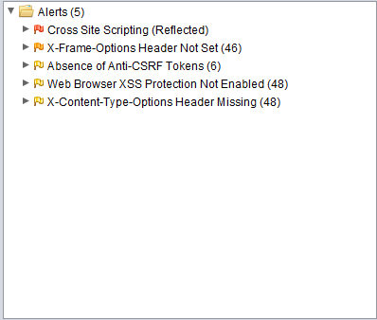

Software Vulnerability Tools

* ZAP
* Selenium
* Manual Testing



Zetksm1@student.op.ac.nz by Stefan Zetko